
中 国 长 春 新 产 业 光 电 技 术 有 限 公 司
Changchun New Industries Optoelectronics Tech. Co.，Ltd
Tel:0086-431-87032275 Fax: 0086 431 87020258
Website: http://www.cnilaser.com
E-mail：sales@cnilaser.com

Testing Reports
All testing is based on the required specifications in the purchase order.

Inspection reports:
Model：FL-266-Nano (SN:CD41608) SIG04 X2021030313
Items of specs | Testing
Wavelength | 266.101nm | See Graph1
Output Power | 114mW@100kHz | See Graph2
Power Stability | 0.849%@100kHz | See Graph2
Operating Mode | Pulsed | /
Pulse Width | 9.055ns@100kHz | See Graph3
Frequency | 100kHz~1MHz | See Graph4
M² | 1.2 | See Graph5
Polarization ratio | >15dB | /
Dimensions of Laser | 330×280×110 mm³ | /
Dimensions of Laser Head | 350×190×65 mm³ | /
Weight of Laser | 10.9 kg | /
Power Supply | DC 12V | /
Warranted Diode Lifetime | 12 months | /

Attachments

Graph1. Wavelength testing

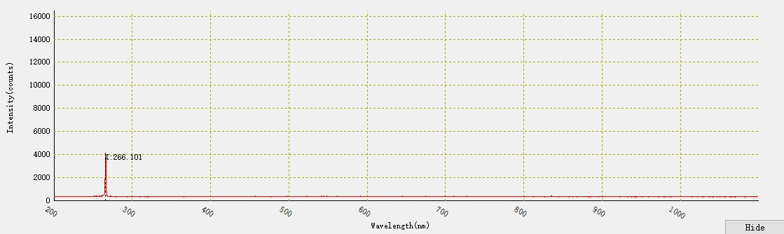

Wavelength tested by ocean spectrograph

Graph2. Power and stability testing

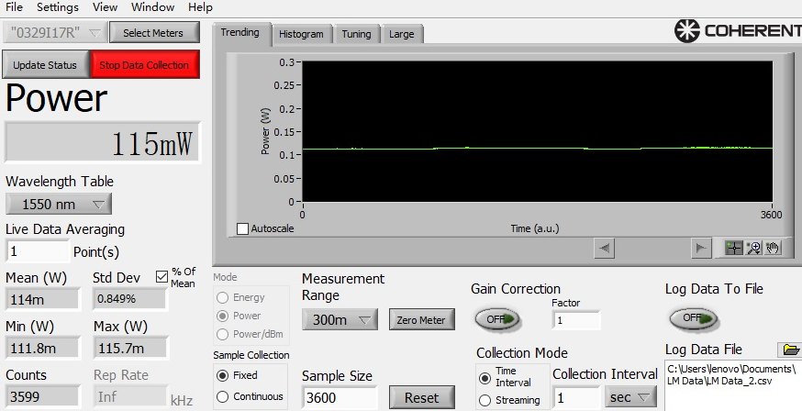

Power and stability tested by Coherent power meter

Graph3. Pulse width testing
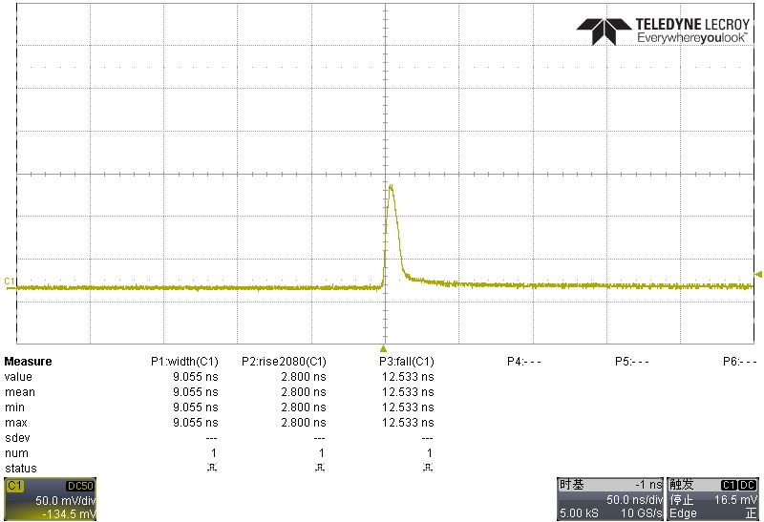
Pulse width tested by LK oscilloscope is 9.055ns

Graph4. Frequency testing

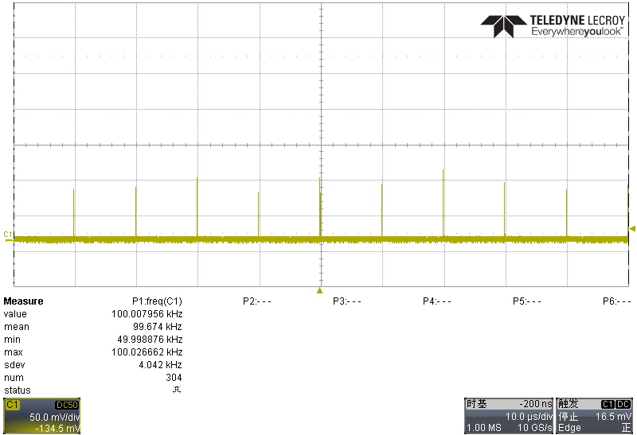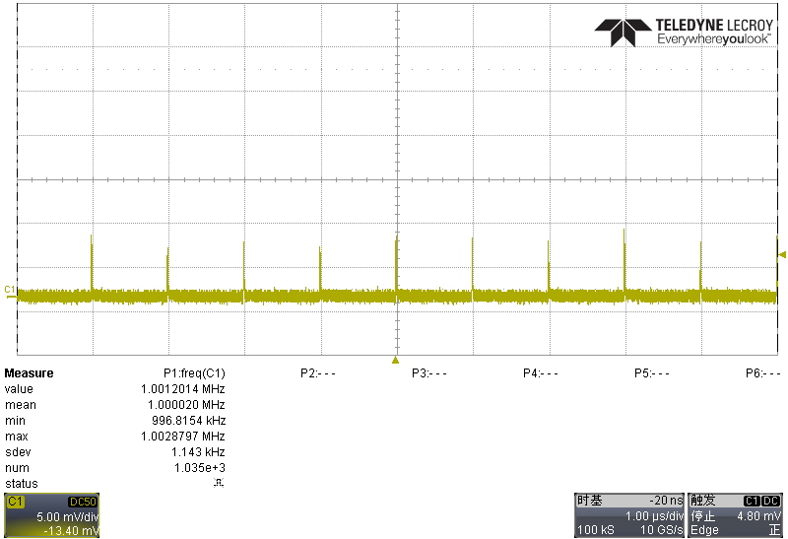
100kHz 1MHz

Graph5. M² testing

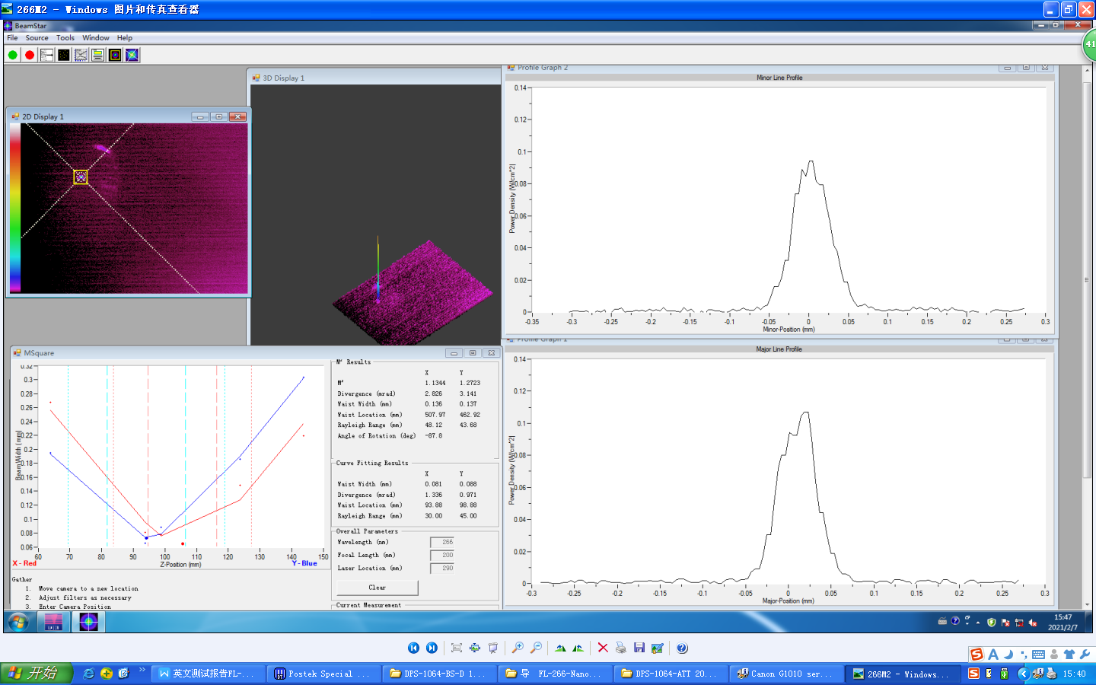

M²=1.2

Graph6. Data testing

Current(%) | Power(mW)
10 | 3.0
20 | 5.5
30 | 10.2
40 | 9.1
50 | 19.2
60 | 28
70 | 45
80 | 64
90 | 91
100 | 117

